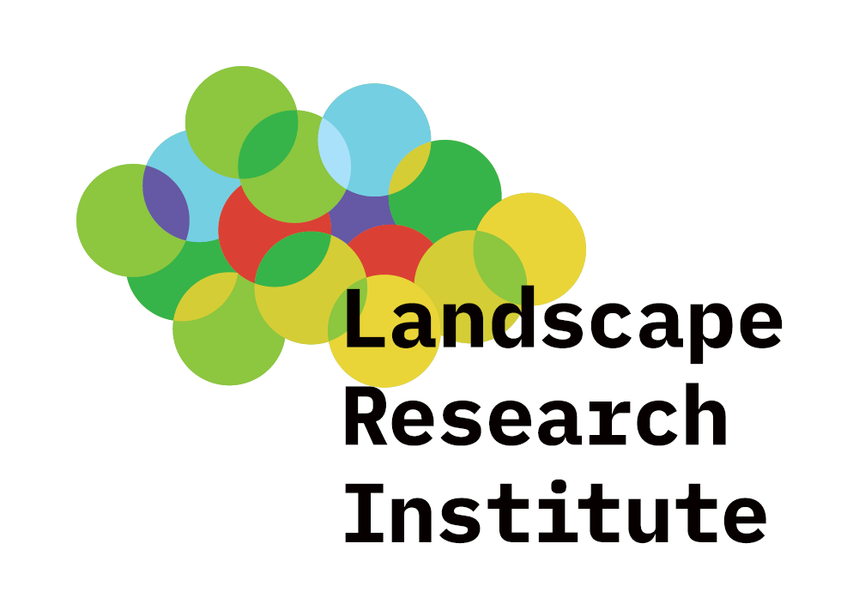LANDSCAPE RESEARCH INSTITUTE
Květnové náměstí 391, Průhonice, 252 43 Czech Republic
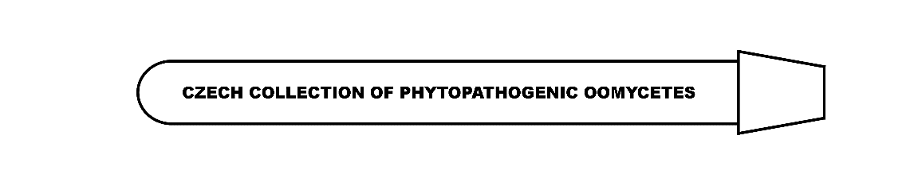
CZECH COLLECTION OF PHYTOPATHOGENIC OOMYCETES (CCPO)

Material Transfer Agreement (MTA)
for non-commercial use

Definitions:
PROVIDER: Czech collection of phytopatogenic oomycetes, Landscape research institute, publ. res. inst. (hereinafter the “Collection”). The Collection is represented by the Head of Collection, Markéta Hrabětová, M. Sc., marketa.hrabetova@vuk.gov.cz, phone +420 296 528 368
RECIPIENT: The entity to which the material is provided and which is stated in the invoice or in the delivery note if different from the invoice. The entity is clearly legally identified..
USER: A specific person who is in an employment relationship with the Recipient and who is the end user.
MATERIAL: Biological material taken from the original deposited culture and delivered to the User by the Provider. Material specification is given in the delivery note and the annex thereto. Material can be living or non-living biological material identical to the primarily deposited material as well as its derivative even if it does not contain any functional units of heredity.
NON-COMMERCIAL USE: Such use of material which is not intended to make profits (such as research, education).

Terms:
I. The Provider is the owner of the Material and any and all rights related thereto. Along with transferring the Material, no intellectual property rights or licensing rights are transferred.

II. The Provider provides the Material to the Recipient, granting the Recipient limited non-exclusive rights thereto according to the conditions laid down in this MTA. The Recipient accepts the Provider’s conditions stated herein by taking over the Material and signing this MTA.

III. The Recipient is, in particular, not allowed:
a) to sell, lend or provide the Material to a third party,
b) to exercise licence rights to the Material,
c) except for the provision of X.a), the Recipient is not allowed to use, in any way whatsoever, the Provider’s name without prior written consent (such as for promotional and advertising purposes),
d) to use the Material for commercial purposes. The use of the Material or its derivative for commercial purposes is permitted only on the basis of a new written agreement with the Provider while respecting the terms and conditions of the Nagoya Protocol.

IV. The Recipient is not allowed to test the Material on humans.

V. The Recipient agrees that the Material provided is of an experimental nature, any treatment thereof being on the Recipient’s own responsibility, in accordance with the applicable laws of the Czech Republic.

VI. Both the Provider and the Recipient are aware that the Material may have properties that are unknown or difficult to identify which may constitute a risk related to the handling, transport, storage or any other treatment of the Material. The Recipient assumes full responsibility for these risks. The Provider shall in no case be responsible for complaints and claims of the Recipient or any third party arising from characteristics of the Material mentioned above. The Recipient undertakes not to shift responsibility for the above to the Provider.

VII. The Recipient is entitled to use the Material within the Recipient’s organisational unit. The User is responsible for familiarizing all staff who will use the Material with the terms and conditions laid down in this MTA.

VIII. The Recipient is entitled to use the Material in any manner permitted by law for scientific and research, teaching and other non-commercial purposes. If the Material is intended to be used in a manner other than those stated in Annex 1 hereto, the Recipient undertakes to notify the Provider of this intent and to open negotiations with the Provider on the conditions of the use of the Material without any delay. The Recipient is not entitled to use the Material for other purposes without the Provider’s consent.

IX. The Provider is not responsible and liable for any damage caused by the use, storage and treatment of the Material. The Provider does not assume any responsibility for patent, trademark and other industrial property rights infringements resulting from the Recipient’s conduct. The Provider shall not be held responsible for any loss, theft, destruction of the Material, except in cases of proven fault on the part of the Provider in connection with the preparation or distribution of the Material; in such a case, the Provider undertakes, after receiving a written complaint, to replace the Material at its own expense.

X. The Recipient undertakes:
a) to clearly and properly state the designation and the origin of the Material in any form of publication (i.e. to state the full collection number of the Material including the collection acronym and the origin of the Material).
b) to provide the Provider, after publishing, with at least an electronic copy of each text or image publication, including electronic publications, made by the Recipient that contain information regarding the Material.
c) to provide the information that by the use of the Material for the declared purposes a result subject to industrial property protection has been created (such as technical solutions protected by a patent or utility model); the Recipient is obliged to notify the Provider without any delay once it decides to apply for industrial property protection. Within 30 days of the receipt of the information on the intent to apply for industrial property protection, the Provider is obliged to express its interest in a joint application for the registration of the result. The Provider is not allowed to use the information obtained from the Recipient in connection with the above situation for its own purposes and to make it available to third parties without the Recipient’s consent.

XI. The Provider undertakes to process the order of the Material (packing, transport, information on the Material and its treatment) in accordance with the applicable Czech and EU law.

XII. Term of MTA. Unless agreed otherwise, the Material shall be provided to the Recipient for an indefinite period of time.

XIII. This Agreement shall be governed by the law of the Czech Republic. Any disputes arising from this Agreement shall be resolved by Czech courts of general jurisdiction.

¨

LANDSCAPE RESEARCH INSTITUTE
Květnové náměstí 391, Průhonice, 252 43 Czech Republic
CZECH COLLECTION OF PHYTOPATHOGENIC OOMYCETES (CCPO)
Material Transfer Agreement - Annex 1 (Order form):
Material (material identification – name of organism, collection number)
Name of organism | Collection number

Purpose of the use of the Material (e.g. planned research, description of the research project, project identification – if already approved, name of training course, objective of the planned breeding):

Recipient (name, address and clear identification of the entity):

User (name of the researcher or teacher responsible for the use of the Material under MTA, contact address, including e-mail):

I hereby declare that I agree with all provisions of the Material Transfer Agreement

Date, name and signature of the statutory representative of the Recipient

…………………………………………..
Date, name and signature of the Head of Collection

…………………………………………….

